**Challenge Tires London & South East Cyclo-Cross League Round 2**

**Sunday 21st September 2025**

**Crystal Palace**

**Crystal Palace Park,**

**Anerley Hill,**

**Sydenham,**

**London,**

**SE19 2BA**

[**https://what3words.com/body.bars.flame**](https://what3words.com/body.bars.flame)

**Technical Manual. Class – British Cycling Category B**

## **Introduction**

Brixton Cycles Club welcomes you to Crystal Palace for round 2 of the Challenge Tires London and South East Cyclo Cross League. An iconic Cyclo Cross venue that once hosted the World Cyclo Cross Champs in 1973.

## **About the course**

Riding in reverse from the previous years; gridding will take place near the infamous Dead Mans Corner. The start goes straight up the hill on tarmac before joining the grass opposite the iconic Laptop stage. The course then turns left onto the finish straight before turning left onto the grass. Expect a fast and flowing descent down to the skate park where uneven rolling banks take riders through a double crossing point and up onto the area of the park in front of the National Sports Centre. The course has long sections of straight and off camber before weaving through the trees taking riders back to the skate park. The course directs riders into an area dominated by oak trees and acorns, before a long section of off camber takes riders past the gridding area and in front of the maze. Expect another cross point for entry into the maze, before taking in a technical course and uphill hurdles before joining the finish straight and the action starts all over again.

**Equipment Pits**

**Please no jet washes in the pits or anywhere in the park.**

Please only access the Equipment pits if you are supporting a rider.

We will have a double pit on the course defined by yellow flags, this will be located close to the Start/Finish area. Servicing and the changing of bicycles will only be allowed in these pits. A rider may only take the pit lane with the intention of changing a bicycle, wheel or receiving mechanical assistance.

We would really appreciate it if all competitors and supporters show great care to ensure that equipment is placed in a manner that allows free movement through the pit area/s. When holding a bike for a rider please make sure that you do not impede another helper or rider. We rely upon you to self-police the pits rather than place the burden on the already very busy commissaires. The commissaires may be there in attendance to provide guidance and direction.

If you are planning to have a spare bike then we advise you purchase a spare bike number as this has the timing chip in it. If you use a bike without one then you go invisible to the timing system and it relies on manual scoring and a clever process in the timing software that predicts you position in the race, however this has to be manually verified and slows down confirming a result for the prize presentation.

We also ask that riders only place their equipment in the pits just before their race and not whilst another race is still on to avoid congestion.

## **Travelling to the event**

**By Train/ London Overground**

Crystal Palace station is in the park itself and just a 5 mins walk to the course.

Penge West, Penge East, Gipsy Hill, Sydenham, Sydenham Hill will get you in the vicinity of the Park, but you will need to climb up the hill.

**By car**

We strongly recommend travelling by public transport – parking space can be limited and is now pay and display. If driving is your only option, enter the park from Anerley Hill, and follow the parking instructions below.

## **Sign on**

**All riders must have their race numbers attached to their bike for the practice sessions.**

**Sign on will be open from 8.30am**

Please collect your race number pack from the Sign on in the Brixton Cycles gazebo. You will need to keep these and bring them every time you race in this year’s league.

We suggest you allocate 5 minutes to set up the number pack and timing chip. Riders are not required to sign anything, and are to use their race number for all events in the League. Riders will be confirmed at the event by the timing system picking up their timing chip at the start of the race. This means that you will not have to revisit sign-on at any other event you enter in advance once you have your race number pack.

If you have ordered a 2nd bike number, follow the same process as above.

If you have forgotten your numbers, you will need to visit the timing tent and collect a ‘temporary set’ which you must return after your race. This will be your race number for the day only.

**Return of last year’s number pack**

In our drive to keep costs down to you as riders and recycle equipment as much as possible, we really would like you to return your number tail fins and jersey numbers from previous seasons. There will be a marked crate at Sign on for you to do this.

## **Toilets**

Toilets are situated as detailed on the map below.

**Course map Full**

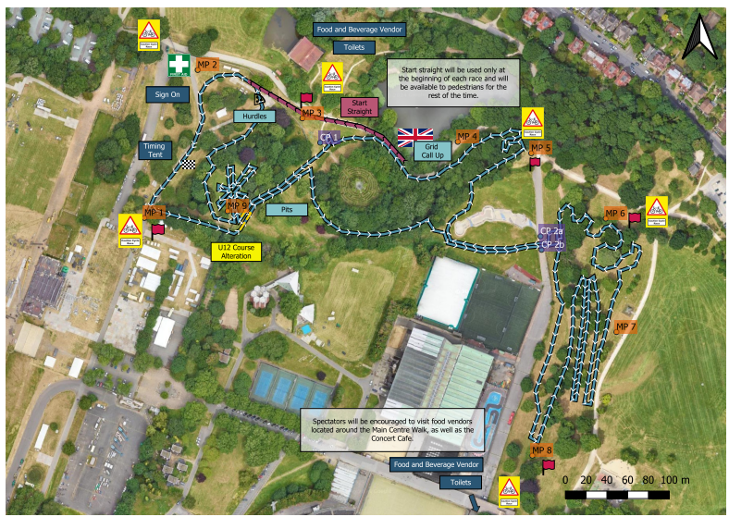

**Please note the pits are only shown for reference, they are not open during the U8/10/12 races.**

**Catering**

The Concert Cafe located near to the landmark Crystal Palace Bowl and toilets will be open to provide food and coffees. There are additional food options and toilets located at the Main Centre Walk near to the Penge entrance.

## 

## **Parking**

Parking space is limited and shared with other park users. Please arrive early if driving is your only travel option.

Enter Crystal Palace Park from Anerley Hill, and follow the road straight down, through the yellow barriers (one has a height restriction - avoid it if you exceed the limit!). Park in the car park on the right at the bottom of the road - please don’t park on the side of the road. Postcode for sat nav is SE19 2GA.

**Please note the car parking is now Pay and Display.**

## **Event Officials**

**Chief Marshal –** Rory Kemper

**Chief Judge –** LCCA Timing Team

**Timekeeping –** LCCA Timing Team Richard Hayes

**British Cycling Chief Commissaire –** Neil Simpson

**British Cycling Commissaire 2 –** Peter Lloyd

**British Cycling Commissaire 3 –** Sarah Cook

**Course Design –** Mon Zamojska

**First Aid Provider –** Emats Limited

**Governing Body –** British Cycling

## **Race Programme and timetable**

|  |  |  |  |
| --- | --- | --- | --- |
| **Race** | **Gridding** | **Race Start** | **Duration** |
| Practice 1 U8/10/12 (Short Course Only) | **9am to 9.15am** | | |
| Under 10 | 9.15 | 9.20 | 10 mins |
| Under 8 (Line up behind the U10’s) | 9.15 | 9.20 | 10 mins |
| Under 12 | 9.35 | 9.40 | 15 mins |
| Practice 2 (Full Course) | **10am to 10.35am** | | |
| Under 14/16 | 10.35 | 10.40 | 30 mins |
| Junior + V40 Open | 11.20 | 11.30 | 40 mins |
| Female (All Cats) | 12.20 | 12.30 | 40 mins |
| Practice 3 | **13.20 to 13.45** | | |
| Vet 50/60/70+ Open | 13.45 | 13.50 | 40 mins |
| Senior Open | 14.40 | 14.50 | 60 mins |

**Practice times** – Please note that course open times are provisional as dependent on lap times and conditions. Please look for the green course open and red closed flags for accurate info on when you can get on course.

**Gridding** – Gridding will be created for each event race and advertised on the league results website and by email before the event, any queries in gridding may be raised on Friday via email [here](mailto:admin@londonxleagueresults.co.uk). Please visit the London and South East Cyclo Cross League Website [rules section](http://www.londonxleague.co.uk/rules/) for a full explanation of how the gridding has been created.

All decisions on gridding rest with the chief commissaire whose decision is final.

## **Podium Presentation times and results**

|  |  |
| --- | --- |
| **Podium Presentation** | |
| U8/10/12 (18) | 10.15 |
| Youth (12) | 11.45 |
| Vet 40/Jun Open and All Female Categories (24) | 13.30 |
| Vet 50/60/70+ Open (6) | 15.00 |
| Senior/U23 Open (6) | 16.00 |

**Results**

Race Results and overall league tables will be published online as soon as feasible [here](https://www.londonxleagueresults.co.uk/) after each race. Race queries can be made up to 6pm on the Tuesday after each race by emailing [admin@londonxleagueresults.co.uk](mailto:admin@londonxleagueresults.co.uk). Once finalised, the results will be sent to BC to update events page and allocate national rankings points.

## **Technical Regulations**

The event is run under the rules of the British Cycling Federation

<https://www.britishcycling.org.uk/cyclocross/article/bcst_rulebook_and_constitution?c=EN>

London and South East Cyclo Cross rules and info on league available here <http://www.londonxleague.co.uk/rules/>

Results will be published on the London and South East Cyclo Cross website and Facebook pages pretty much on the day of racing

Any queries on results please visit here for info how to do this [admin@londonxleagueresults.co.uk](mailto:admin@londonxleagueresults.co.uk).

## **First Aid and local hospitals**

## **EMATS Limited**

## Garland House,

## Desborough Avenue,

## High Wycombe,

## Bucks,

## HP11 2RN

## 0330 175 9971

## www.emats.co.uk

Local Hospitals:

St George’s A&E, (6.5 miles)

St George’s Hospital, London,

SW17 0QZ

020 8672 1255