
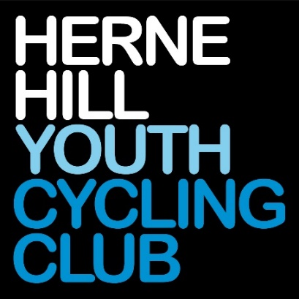

Challenge Tires

London & South East Cyclo-Cross League
Round 4

Sunday 4th October 2026

Herne Hill Velodrome, Burbage Road, Herne Hill
London SE24 9HE

What3words ///forget.precautions.basic




Technical Manual. Class – British Cycling Category B

Introduction

Herne Hill Youth CC welcomes you to the Round 4 of the Challenge Tires London & South-East Cyclo-cross League, at Herne Hill Velodrome in South London. While it is best known as a regional venue for track cycling, its tight and twisty off-road trails make it a very popular cyclo-cross venue.

About the course
- We’ll be using many of the new off-road features on the trails, including the “Camel Humps”, “Rollers”, up “Big Bob” and descending “Little Bob”.
- Riders start in the centre of the Velodrome and then head north past the finish line to exit the track just after a hairpin.
- An off-camber path, slightly bumpy path leads us around the north of the track, then a fast turn into an off-camber descent. A steep dirt climb is followed by a slightly off-camber descent and a climb back up towards the camel humps. The U8/10/12 route instead turns right to take the tracks around the back of the Meadows.
- Camel humps: Sharp right-hand turn off the second camel hump, with a B-line available for riders who need it. We then follow the fast tracks around the meadows and back over the Rollers.
- We’ll be ascending steps then a sharp left into the zig-zags and then towards Big Bob.
- Big Bob and Little Bob: U8/10/12 will cut off before the ascent of Big Bob. A small drop-off on the approach to the Big Bob climb requires riders to stay close to the wall; the Little Bob descent ends in a sharp left.
- Return to the velodrome: We then approach the track gate, then take a sharp turn at the foot of the track crossing. Here, U8/10/12 will turn right and begin a new lap.
- Infield finale: Adjustable hurdles will be found at the south end of the infield and we’ll then be spelling HHYCC before recommencing the lap.

Equipment Pits
Please only access the Equipment pits if you are supporting a rider.
There are two pits, defined by yellow flags. PIT 2 is in the meadows, just after the Rollers and PIT 1 is inside the track on the South side bend. just before the finish and has the most space for equipment. PIT 1 is accessible to pit crew via a gate by track finish line.
Servicing and the changing of bicycles will only be allowed in these pits. A rider may only take the pit lane with the intention of changing a bicycle, wheel or receiving mechanical assistance.
We would really appreciate it if all competitors and supporters show great care to ensure that equipment is placed in a manner that allows free movement through the pit areas.
When holding a bike for a rider please make sure that you do not impede another helper or rider.
We rely upon you to self-police the pits rather than place the burden on the already very busy commissaires. The commissaires may be there in attendance to provide guidance and direction.
If you are planning to have a spare bike then we advise you purchase a spare bike number as this has the timing chip in it. If you use a bike without one then you go invisible to the timing system and it relies on manual scoring and a clever process in the timing software that predicts your position in the race, however this has to be manually verified and slows down confirming a result for the prize presentation.
We also ask that riders only place their equipment in the pits just before their race and not whilst another race is still on to avoid congestion.

Travelling to the event
Herne Hill Velodrome can be found at 104 Burbage Road SE24 9HE. It is close to the South Circular Road A205 in Dulwich.
There is very limited parking onsite, so if you can, please try to arrive by bike, or by public transport. Nearby rail stations include Herne Hill, North Dulwich, Tulse Hill, and West Dulwich.
PLEASE NOTE: The velodrome has an arrangement with its neighbours not to open before 8.30am on Sundays. Please aim to arrive at or after 8.30am so as not to clog up the street before the gate opens!
The onsite parking is expected to fill up early on, after which time it will be necessary to find local on-street parking. Do please be considerate to our neighbours and be careful not to block driveways. There are changing facilities, toilets and space to put rollers within the velodrome - please use these and don’t change or warm up in the streets.
While the Velodrome is outside the congestion charge zone, it is WITHIN the ULEZ zone, which is in operation 24/7. There is a £12.50 daily charge for older vehicles (NB make sure you only pay via official TfL websites, as there are some fraudulent ones out there!)

Sign on
If you have entered earlier rounds and already have your back number and tailfin number, you need to bring these. If you already have your numbers you will not need to visit sign on for this race.
If this event is the first time you have raced in the London & South East League this season, please collect your race numbers from next to the catering tent in the track centre. You will need to keep these and bring them every time you race in this year’s league.
We suggest you allocate 5-10 minutes to set up the number pack and timing chip. Riders are not required to sign anything, and are to use these race numbers for all events in the League. Riders will be confirmed at the event by the timing system picking up their timing chip at the start of the race. This means that you will not have to revisit sign-on at any other event you enter in advance once you have your race number pack.
If you have ordered a 2nd bike number for a spare bike, follow the same process as above.
If you have forgotten your numbers, you will need to visit the timing tent and collect a ‘Bib of Shame’ which you must return after your race. This will be your race number for the day only.
Return of last year’s number pack
In our drive to keep costs down to you as riders and recycle equipment as much as possible, please dig out and return your number tail fins and jersey numbers from previous seasons. There will be a marked crate at Sign on for you to do this.

Warming up
All riders must have their race numbers attached to their bike for the practice sessions. You may only practice on the course when the green ‘Course Open’ flag is displayed.
Please DO NOT ride on the velodrome or on the inner track while warming up - we have to clean all the crossing points at the end of the day to prevent punctures for other venue users.
There is a bike wash just outside the container area (see map), you are welcome to use this for free (so long as the water butt lasts).

Toilets
Toilets, changing rooms and showers are on the ground floor of the pavilion.
If it’s wet, please take muddy shoes off before entering the pavilion.

Catering

Food and drink are provided at two outlets:
Herne Hill Youth CC Catering tent
- Barbeque (including veggie options)
- tea/coffee/squash
- amazing cakes and biscuits

Jan’s Cafe (upstairs in the pavilion)
- Chips
- toasties
- tea/coffee/beer

Course map
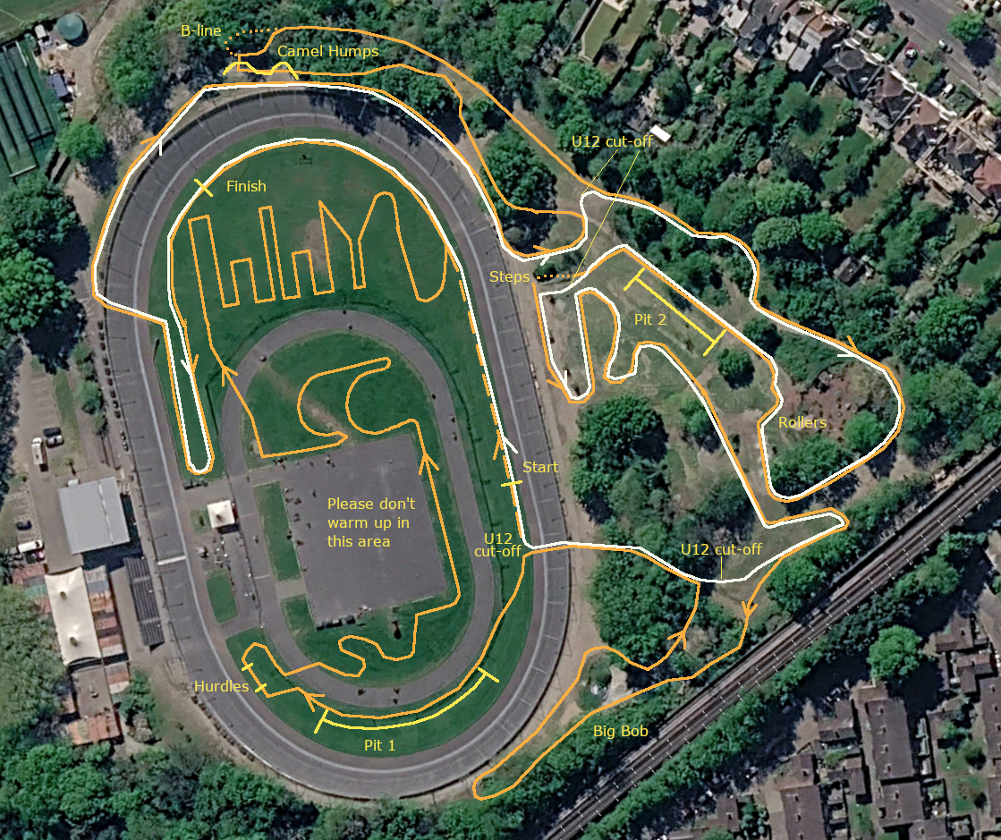

Race Programme and timetable

Race | Gridding | Race Start | Duration
Practice 1 U8/10/12 | 9am to 9.15am
Under 10 | 9.15 | 9.20 | 10 mins
Under 8 | 9.15 | 9.20 | 10 mins
Under 12 | 9.35 | 9.40 | 15 mins
Practice 2 | 10am to 10.35am
Under 14/16 | 10.35 | 10.40 | 30 mins
Junior/Masters 40 Open | 11.20 | 11.30 | 40 mins
Female (All Cats) | 12.20 | 12.30 | 40 mins
Practice 3 | 13.20 to 13.45
Masters 50/60/70+ Open | 13.45 | 13.50 | 40 mins
Senior/U23 Open | 14.40 | 14.50 | 60 mins

Practice times – Please note that course open times are provisional as dependent on lap times and conditions. Please look for the green course open and red closed flags for accurate info on when you can get on the course.

Gridding – Gridding will be created for each event race and advertised on the league results website and Facebook page before the event, any queries in gridding may be raised on Friday via email as posted on the results site. Please visit the London and South East Cyclo Cross League Website rules section for a full explanation of how the gridding has been created.

Podium Presentation times and results

Results
Race Results and overall league tables will be published online as soon as feasible after each race. Race queries can be made up to 6pm on the Tuesday after each race by emailing admin@londonxleagueresults.co.uk. Once finalised, the results will be sent to BC to update events page and allocate national rankings points.

Podium Presentation
U8/10/12 (18) | 10.15
Youth (12) | 11.45
Masters 40/Jun Open and All Female Categories (24) | 13.30
Masters 50/60/70+ Open (9) | 15.00
Senior/U23 Open (6) | 16.00

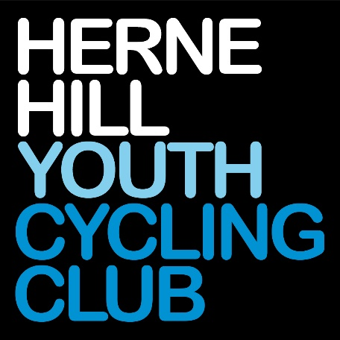

Event Officials

Event Organisers – Oliver Lewis ollylewis75@gmail.com
Laurent Schonbach: lschonbach@outlook.com
British Cycling Chief Commissaire – Sarah Cook
British Cycling Commissaire 2 – Julian Campbell
British Cycling Commissaire 3 – Chris Clague
Chief Marshal – Oliver Lewis
Timekeeping – LCCA Timing Team
Course Design – Barney & Elliot Howard
Landscaping – Capability Charlie Codrington
First Aid Provider – EMATS
Governing Body – British Cycling
Cakes, Biscuits & BBQ – Members of HHYCC

Technical Regulations

The event is run under the rules of the British Cycling Federation:
https://www.britishcycling.org.uk/cyclocross/article/bcst_rulebook_and_constitution
London and South East Cyclo Cross rules and info on league available here: http://www.londonxleague.co.uk/rules/
Results will be published on the London and South East Cyclo Cross website and Facebook pages pretty much on the day of racing.
Any queries on results please visit here for info how to do this: admin@londonxleagueresults.co.uk.

First Aid and local hospitals

First Aid is provided by:

EMATS Limited Garland House,

Desborough Avenue,

High Wycombe,

Bucks,

HP11 2RN 0330 175 9971

www.emats.co.uk

Local Hospitals:

Kings College Hospital (2 miles)
Denmark Hill
London SE5 9RS
020 3299 9000

St George’s Hospital (4 miles)
Blackshaw Road
London SW17 0QT
020 8672 1255



