



Challenge Tires London & South East Cyclo-Cross League Round 3
Sunday 27th September 2026

Crystal Palace

Crystal Palace Park,
Anerley Hill,
Sydenham,
London,
SE19 2BA

https://what3words.com/body.bars.flame
Technical Manual. Class – British Cycling Category B

Introduction

Brixton Cycles Club welcomes you to Crystal Palace for round 3 of the London and South East Cyclo Cross League. An iconic Cyclo Cross venue that once hosted the World Cyclo Cross Champs in 1973.

About the course

This year the gridding will take place near Fishermans Corner. The start goes straight up the hill on tarmac, then onto grass before turning right, crossing the tarmac and onto the grass in front of the iconic Laptop stage. The course crosses in front of the stage that played host to Bob Marley’s last UK gig, before moving into a technical tight turns behind the stage. Watch out for a narrow section that takes you back into the bowl where you complete a circuit of perimeter the bowl and cross into a small wooded area where you’ll have to weave through the trees. Turning left onto the finish straight has a section of tarmac before turning right onto the grass and weaving through larger trees the riders will pass the double entry pits before an enjoyable fast single track descent down to the skate bowl and past the National Sports Centre. Unlike last year, we avoid the acorns and bank of the southern terraces but instead loop around the skate park and enter the wooded area below fishermans corner where you’ll go up and down the bank before being directed onto a long off camber section taking riders past the gridding area and in front of the maze. Once again you’ll pass the pits, hurdles, before crossing the tarmac and once again looping around the bowl.
Equipment Pits
Please no jet washes in the pits or anywhere in the park.
Please only access the Equipment pits if you are supporting a rider.
We will have a double pit on the course defined by yellow flags, this will be located close to the Start/Finish area. Servicing and the changing of bicycles will only be allowed in these pits. A rider may only take the pit lane with the intention of changing a bicycle, wheel or receiving mechanical assistance.

We would really appreciate it if all competitors and supporters show great care to ensure that equipment is placed in a manner that allows free movement through the pit area/s. When holding a bike for a rider please make sure that you do not impede another helper or rider. We rely upon you to self-police the pits rather than place the burden on the already very busy commissaires. The commissaires may be there in attendance to provide guidance and direction.

If you are planning to have a spare bike then we advise you purchase a spare bike number as this has the timing chip in it. If you use a bike without one then you go invisible to the timing system and it relies on manual scoring and a clever process in the timing software that predicts you position in the race, however this has to be manually verified and slows down confirming a result for the prize presentation.

We also ask that riders only place their equipment in the pits just before their race and not whilst another race is still on to avoid congestion.

Refreshments and Bottle/Gel hand-ups at League races

A few riders have been asking what's allowed when it comes to drinks and food during a race. We want everyone, riders and parents, to be clear on this before race day, so here's a straightforward rundown.
We follow British Cycling rules for all races in the League.
You cannot do this, at any race:

- Be handed a bottle, gel or any other refreshment by anyone, family, pit crew or spectators, during the race. This is "unauthorised feeding" under British Cycling rules and it's a disqualification offence.

You can always do this, at every race, no permission needed:

- Carry your own food, gels or a drink on your bike or on you, and eat or drink whenever you like during the race.
- Collect a spare bike from the pits with a bottle already fitted to it. That's a bike change, not a hand-up, so it's fine.

The one exception, Senior, Youth, Junior and Master races only:
The Chief Commissaire has discretion to allow bottle or gel hand-ups. The Commissaire teams across the South East region have agreed a threshold for this: the Chief Commissaire may use their discretion to allow bottle hand-ups in the pits when the race-day temperature reaches 25°C. This keeps the decision consistent from race to race, rather than down to whoever is on duty that day. If the forecast for a round is 25°C or above, the technical guide will flag that hand-ups may be permitted, with the final decision confirmed at the start-line briefing.

Under 8, Under 10 and Under 12 races:

No hand-ups at all, at any temperature. These races have no pits and no bike changes are allowed. Bring what you need on the bike or in a pocket.

If in doubt, don't hand anything to a rider during a race, ask the Chief Commissaire first.

¹ Full rules: British Cycling Handbook 2026, Cyclo-Cross Technical Regulations, clauses CX8.1, CX8.6, CX8.7 (Page 70) and Appendix CX1 (pages 72-73). Available via britishcycling.org.uk/about/article/bcst_rulebook_and_constitution.

Travelling to the event

By Train/ London Overground

Crystal Palace station is in the park itself and just a 5 mins walk to the course.
Penge West, Penge East, Gipsy Hill, Sydenham, Sydenham Hill will get you in the vicinity of the Park, but you will need to climb up the hill.

By car

We strongly recommend travelling by public transport – parking space can be limited and is now pay and display. If driving is your only option, enter the park from Anerley Hill, and follow the parking instructions below.

Sign on

All riders must have their race numbers attached to their bike for the practice sessions.

Sign on will be open from 8.30am
Please collect your race number pack from the Sign on in the Brixton Cycles gazebo. You will need to keep these and bring them every time you race in this year’s league.
We suggest you allocate 5 minutes to set up the number pack and timing chip. Riders are not required to sign anything, and are to use their race number for all events in the League. Riders will be confirmed at the event by the timing system picking up their timing chip at the start of the race. This means that you will not have to revisit sign-on at any other event you enter in advance once you have your race number pack.
If you have ordered a 2nd bike number, follow the same process as above.
If you have forgotten your numbers, you will need to visit the timing tent and collect a ‘temporary set’ which you must return after your race. This will be your race number for the day only.
Return of last year’s number pack
In our drive to keep costs down to you as riders and recycle equipment as much as possible, we really would like you to return your number tail fins and jersey numbers from previous seasons. There will be a marked crate at Sign on for you to do this.

Toilets

Toilets are situated as detailed on the map below.
Course map Full
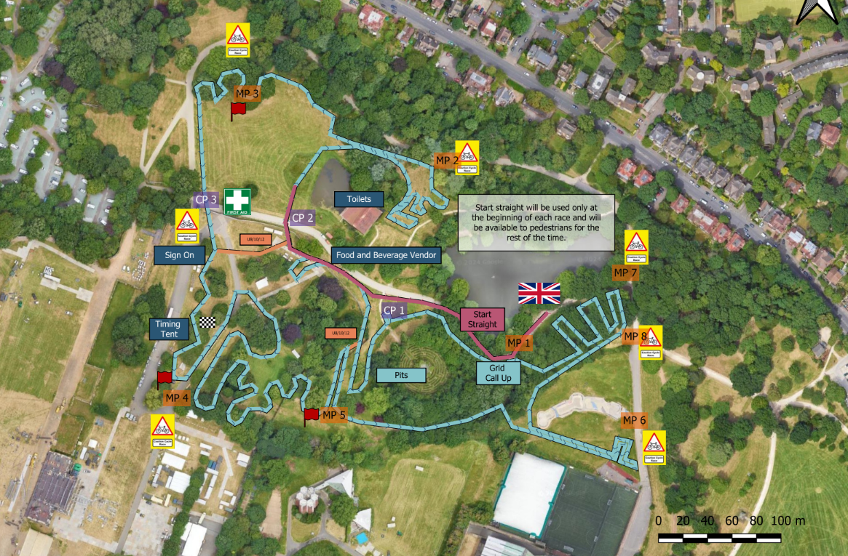
Please note the pits are only shown for reference, they are not open during the U8/10/12 races.
Catering
There will be hot food by Maureen’s Brixton Kitchen and cold brews from Volanco Coffee near the sign on tent. The Concert Cafe located near to the landmark Crystal Palace Bowl and toilets will be open to provide food and coffees. There are additional food options and toilets located at the Main Centre Walk near to the Penge entrance.

Parking

Parking space is limited and shared with other park users. Please arrive early if driving is your only travel option.
Enter Crystal Palace Park from Anerley Hill, and follow the road straight down, through the yellow barriers (one has a height restriction - avoid it if you exceed the limit!). Park in the car park on the right at the bottom of the road - please don’t park on the side of the road. Postcode for sat nav is SE19 2GA.
Please note the car parking is now Pay and Display.

Event Officials

Chief Marshal – Rory Kemper
Chief Judge – LCCA Timing Team
Timekeeping – LCCA Timing Team Richard Hayes
British Cycling Chief Commissaire – Chris Clague
British Cycling Commissaire 2 – Julian Campbell
British Cycling Commissaire 3 – TBC
Course Design – Mon Zamojska and Nat Cooke
First Aid Provider – Emats Limited
Governing Body – British Cycling

Race Programme and timetable

Race | Gridding | Race Start | Duration
Practice 1 U8/10/12 (Short Course Only) | 9am to 9.15am
Under 10 | 9.15 | 9.20 | 10 mins
Under 8 (Line up behind the U10’s) | 9.15 | 9.20 | 10 mins
Under 12 | 9.35 | 9.40 | 15 mins
Practice 2 (Full Course) | 10am to 10.35am
Under 14/16 | 10.35 | 10.40 | 30 mins
Junior + Masters 40 Open | 11.20 | 11.30 | 40 mins
Female (All Cats) | 12.20 | 12.30 | 40 mins
Practice 3 | 13.20 to 13.45
Masters 50/60/70+ Open | 13.45 | 13.50 | 40 mins
Senior Open | 14.40 | 14.50 | 60 mins

Practice times – Please note that course open times are provisional as dependent on lap times and conditions. Please look for the green course open and red closed flags for accurate info on when you can get on course.

Gridding – Gridding will be created for each event race and advertised on the league results website and by email before the event, any queries in gridding may be raised on Friday via email here. Please visit the London and South East Cyclo Cross League Website rules section for a full explanation of how the gridding has been created.
All decisions on gridding rest with the chief commissaire whose decision is final.

Podium Presentation times and results

Podium Presentation
U8/10/12 (18) | 10.15
Youth (12) | 11.45
Masters 40/Jun Open and All Female Categories (24) | 13.30
Masters 50/60/70+ Open (6) | 15.00
Senior/U23 Open (6) | 16.00

Results
Race Results and overall league tables will be published online as soon as feasible here after each race. Race queries can be made up to 6pm on the Tuesday after each race by emailing admin@londonxleagueresults.co.uk. Once finalised, the results will be sent to BC to update events page and allocate national rankings points.

Technical Regulations

The event is run under the rules of the British Cycling Federation
https://www.britishcycling.org.uk/cyclocross/article/bcst_rulebook_and_constitution?c=EN
London and South East Cyclo Cross rules and info on league available here http://www.londonxleague.co.uk/rules/
Results will be published on the London and South East Cyclo Cross website and Facebook pages pretty much on the day of racing
Any queries on results please visit here for info how to do this admin@londonxleagueresults.co.uk.

First Aid and local hospitals

First Aid is provided by:

EMATS Limited
Garland House,
Desborough Avenue,
High Wycombe,
Bucks,
HP11 2RN
0330 175 9971
www.emats.co.uk

Local Hospitals:

St George’s A&E, (6.5 miles)
St George’s Hospital, London,
SW17 0QZ

