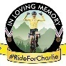

B F C C R A C I N G - X C C S E R I E S 2 0 2 6 , R O U N D 4
E V E N T T E C H N I C A L D O C U M E N T

Saturday 22nd August 2026
Bedgebury National Pinetum and Forest, Park Lane, Goudhurst, Kent, TN17 2SL

BFCC W: www.boarsonbikes.co.uk
BFCC Facebook page: https://www.facebook.com/groups/bedgeburyboars/?locale=en_GB
BFCC Instagram: https://www.instagram.com/boars_on_bikes/

British Cycling Event Info and Sign Up: https://www.britishcycling.org.uk/events/details/338947/BFCC-Racing-XCC-Series-2026---Race-4

Section 1

BFCC RACING, XCC Series 2026, Round 3
British Cycling Non-Ranking Race
Date: Saturday 18th June 2026
Event Location: Bedgebury National Pinetum and Forest, Park Lane, Goudhurst, Kent, TN17 2SL (From the Car Park, follow signs to BFCC Training Area – approx. 15 minutes).
The Training Area (Race Track Sign-On) can also be found using What3Words - ///live.globe.publisher - https://w3w.co/live.globe.publisher
To be held under the technical regulations of British Cycling. British Cycling, National Cycling Centre, Stuart Street, Manchester, M11 4DQ.
Prepared by: Glen Whittington. E: glen@aeightbikeco.com . M: +44/0 7541 725 606

Any proceeds generated from the event will be used to support our Youth and Junior riders in club activities.

Many Thanks to;
All the brilliant BFCC Members who volunteer, plus our friends from SDW and Team Darenth who support our event with marshals and scorers.
Forestry England for the ongoing support of our race.
AEIGHT, who sponsor the number boards, end of season prizes, and support.
Jeremy’s Rides, who support our races.
Schwalbe UK, who are providing some spot prizes via AEIGHT.
Ride For Charlie, who provide our prize bags.
We’re adding sponsors as we go – if you’d be interested in sponsoring our races please get in touch.

Section 2

Event Overview

Bedgebury Forest Cycle Club (BFCC) welcomes you to the “BFCC Racing XCC Series 2026”. Grass roots mountain bike racing at it's very best, featuring a fun sub-4km XCC course through the woodland, based mainly on non-technical single-track and “natural” trails, with shorter loops for the U8, U10 and U12 races.
We welcome riders of all ages and abilities, from first time racers to seasoned experts, offering XC races and categories for U8's to Masters. We use an electronic race timing system to record the riders positions.
This year we have a 3 event race series for the adults (4 events for the U8/10/12/14/16s), with trophies awarded to the top 3 riders in each category across the series. Please make sure you enter the correct age category and race!
Entry is ONLINE ONLY for all U14/Juvenile, U16/Youth, Senior (Inc. Juniors and U23), and Masters - Entry CLOSES AT 23.00 ON THE THURSDAY BEFORE THE EVENT – no late entries!
Entry is on the day for U8s, U10s, and U12s ONLY - Please bring £2 CASH for these categories, NO CARDS TAKEN!
For more information about BFCC and our Race Series, please visit: www.boarsonbikes.co.uk

Section 2 Continued

Info for Riders

10:00 - Sign-On open for all riders
10:05 - Course open for practice laps (All riders – PLEASE ride a practice lap)!
10:45 – Sign-On and Course closed, to allow races to start. Riders must not cross the Finish Line after this time, and must not attempt to rejoin the Under 8/10/12s course at any point.
11:00 – U8s and U10s Race. (10 mins)
11:20 – U12s Race. (15 mins)
12:05 – Senior (Inc. Juniors and U23), and Masters Race. (50 mins)
12:10 – Youth (U16) Race. (45 mins)
12:15 – U8/U10/U12 Podiums, followed by Series Podiums and Prize-giving (approx. 15 mins)
12:25 – Juvenile (U14) Race (30 mins)
13:10 – Final Podiums, followed by Series Podiums and Prize-giving (approx. 15 mins)
You should allow around 15 minutes to make your way from the car park at Bedgebury Visitors Centre to the event HQ. (route is sign posted). At the Bedgebury Visitors Centre you will find toilets, showers and a cafe.
All Senior (Inc. U23) / Masters will ride in the same 50 minutes race on a sub-4km XCC race course, with Youth riders joining 5 minutes after the Senior race has started, followed by Juvenile riders after a further 15 minutes. The U8, U10 and U12 age groups have separate races on a shorter course.
Please note - Forestry Commission parking charges apply if you use the car park at Bedgebury (scan or take a copy of the discount QR code at Sign On).
NO ENTRY ON THE DAY for U14/Juvenile, U16/Youth, Senior (Inc. Juniors and U23), and Masters – Online Entry CLOSES AT 23.00 ON THE THURSDAY BEFORE THE EVENT – no late entries!
On the Day, or Online Entries available for U8s, U10s, and U12s - Please bring £2 CASH for these categories, NO CARDS TAKEN!
For more information about BFCC and our Race Series, please visit: www.boarsonbikes.co.uk

Section 2 Continued

About the course

The course is based around three areas, known as the “Oaks”, the “Firs”, and the “Chestnut Copse”. For the time being the Chestnut area is not available, but we have tweaked and improved the Oaks and Firs area to produce two excellent courses for XCC racing.
Access to the course is via the main gravel fireroad, from the Car Park, and will be sign posted, from the Forest England office (Bike Hire Area) – please DO NOT use ANY of race track to access the course, as there could be a race or practice session on, and you may not know which direction we’re riding in! As you ride/climb up the main gravel fireroad, the training area will be on your right. The Start/Finish/Sign-On area are all in the Training area, and it’s a good place for spectators/supporters/etc.
There should be no reason to cross the course, but if you must, please do so with extreme care, and DO NOT tamper with any tapes or signage.
New course features include “Jeremy’s Chicken Run”, “Matchsticks”, and “Roo’s Shoes”. The start is on the grassy ride to the north of the Sign-On area (on the right, as you enter the Training area). There is plenty of flat grass for racers, but there is limited spectator/helper access – please be sensible about staying off the track. Be aware that there is more than one race start, please do not walk back on the race track.
Course Description: For this race we are going in an ANTI-CLOCKWISE direction. All riders (WITH THE EXCEPTION OF THE U14 and U16 CATEGORIES) will follow the U12 lap for the 1ST LAP, and will keep turning left at both junctions/course changes (MP3 and MP1).
- Under 14s and 16s will join the race once it’s underway and therefore will follow the Full Course.

- U8/10/12s will continue around the same loop for the duration of their race.

- Seniors (Inc. Junior and U23), and Masters will join the Full Course after the “U12” Start Loop, and will then turn right down “Matchsticks” towards the northern end of the course. After MP4 you’ll turn back south into the lower section of the course and then climb up Ride A, turn left into the fir trees and complete this section to MP3. You’ll now rejoin the “Mini Oaks” section, but this time, at MP1, you’ll turn right onto “Chicken Run”, complete this and then head back to the main arena. Across the finish and back round to the start, before completing the same lap as many times as possible in your allotted time. It sounds complicated, but it’ll all make sense on the day thanks to our fantastic marshals.

Section 3

Travelling to the event

By Road (from the North)
On the A21 Southbound, use the left turning onto the B2079 (Lady Oak Lane), before Flimwell, signposted “Bedgebury Pinetum.

By Road (from the South)
On the A21 Northbound, us the right turning onto the B2079 (Lady Oak Lane), after Flimwell, signposted “Bedgebury Pinetum.

By Rail
The nearest rail station is Etchingham and is roughly a 30-45 minute ride.

Accommodation
There is a Motel, close the race venue – Forest Edge Motel
Address: London Road, Flimwell, TN5 7PL
Telephone: 01580 879222

There is also a B&B, within the forest – Bedgebury Bed & Breakfast
Address: Three Chimneys Farm, Bedgebury Road, Goudhurst, TN17 2RA
Telephone: 07762 183110

And there is also camping available via https://www.bedgeburycamping.co.uk/

Accessibility
There are plenty of parking spaces and a toilet at the main Bedgebury Car Park and Visitor area.
There are designated disabled parking spaces and a disabled toilet at the main Bedgebury Car Park and Visitor area.

Section 3 Continued

When you arrive
All riders must have their race numbers attached to their bike for the practice sessions.
You must have filled out the sign-on form and collected a number to be allowed on the course.
It is your responsibility to be on time for your race – we cannot hold races up as the schedule is very busy – PLEASE INCLUDE ENOUGH TIME FOR SIGN ON – We recommend getting there early for sign-on, so you have time to practice!
There are NO toilets in the sign-on/race area. Please make sure you and your riders make use of the facilities at the Car Park/Visitor area before coming up to the Training/Race area.

Age Categories
Under 8: Riders in their 8th birthday year or younger.
Under 10: Riders in their 9th or 10th birthday year.
Under 12: Riders in their 11th or 12th birthday year.
Juvenile (Under 14): Riders in their 13th or 14th birthday year.
Youth (Under 16): Riders in their 15th or 16th birthday year.
Senior: Riders in their 17th – 39th birthday year. (This category includes Juniors)
Masters: Riders in their 40th birthday year or older.

Section 4
Course map
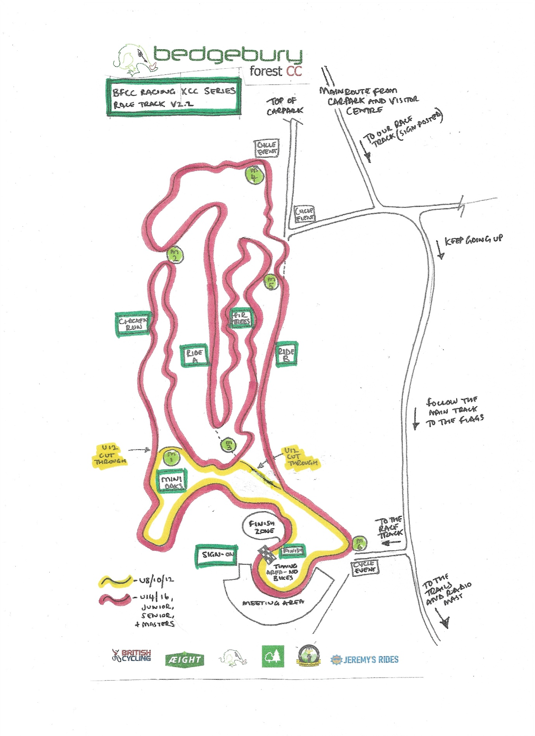

Section 4 Continued

The following points are covered in the maps above.
First Aid – provided by our coaches under BC Rules.
CP – Course crossing points – N/A
Start – at Marshal Point 6
Finish – as marked
Gridding – at “Start” area
NOTE: This course may be subject to change on race day.

Catering
There is a café in the Car-Park/Visitor area – there is nothing onsite at the race area. Please bring refreshments up to the race area.

Spectator Safety
Do not lean over the tape into the course, never move or alter any part of the course, always follow marshal’s/official’s instructions, and pick your spectator areas careful so you don’t negatively affect the racing.

Section 4 Continued

Event Officials

RACE DIRECTOR - Glen Whittington / glen@aeightbikeco.com / M: +44/07541 725606
DEPUTY RACE DIRECTOR / REGISTRATION AREA (and PRIZE GIVING) - Alice Jarvis

DEPUTY RACE DIRECTOR / CHEIF MARSHAL (and FLOATING MARSHAL) - Jeremy Brown

REGISTRATION / SIGN ON – Rachel Stevens, Alice Jarvis and Pip Jenkins

HEAD OF TIMING / RESULTS - Paul Stevens

SCORERS / TIME KEEPERS – Andy Bocking, Sarah Goodman

COURSE DESIGN / RIDER BREIFING - Glen Whittington

STARTER / COURSE SIGN-OFF / RIDER BREIFING – Tim Bizley

FIRST AID - Gary Scott

WELFARE / SAEGUARDING OFFICER - Jeff Mills and/or Vicky Blewett

FIXED POSITION MARSHAL -

MP1 (W3W ///notifying.tigers.torched) Malcom Stoddard
MP2 (W3W ///protester.goggles.opinion) Jeff Mills
MP3 (W3W ///crib.ribcage.tinkle) Terry Jarvis, (and the Terry Jarvis Sound Machine!)
MP4 (W3W /// NEED TO LOG NEW LOCATION) Michael Paine
MP5 (W3W ///brightly.shatters.goofy) Dave Coppins
MP6 (W3W ///adhesive.evoked.tradition) Pip Jenkins

VENUE - Rebecca Dennison / Forestry England

BRITISH CYCLING CHIEF COMMISSAIRE: Chris Clague
BRITISH CYCLING COMMISSAIRE 2: N/A

Section 5

Race Programme and timetable

Practice times – Please note that course open times are provisional as dependent on lap times and conditions. You must have your bike number fitted to your bike for the practice sessions.
Please arrive to the start 10 minutes before your race.

10:00 - Sign-On open for all riders
10:05 - Course open for practice laps (All riders – PLEASE ride a practice lap)!
10:45 – Sign-On and Course closed, to allow races to start. Riders must not cross the Finish Line after this time, and must not attempt to rejoin the Under 8/10/12s course at any point.
11:00 – U8s and U10s Race. (10 mins)
11:20 – U12s Race. (15 mins)
12:05 – Senior (Inc. Juniors and U23), and Masters Race. (50 mins)
12:10 – Youth (U16) Race. (45 mins)
12:15 – U8/U10/U12 Podiums, followed by Series Podiums and Prize-giving (approx. 15 mins)
12:25 – Juvenile (U14) Race (30 mins)
13:10 – Final Podiums, followed by Series Podiums and Prize-giving (approx. 15 mins)

Gridding
Please “self-grid” yourself/your rider – if you think you’ll be in the mix, please go towards the front. If you’re still finding your feet, please grid yourself towards the back and learn from the other racers. The Starter and Commissaire will help you with this.

Pits
There are no pits for this race.

Section 6

Bike Wash Area
There is no specific bike washing area. If you are cleaning bikes in any of the car parks, please be respectful of other Car Park users.

Prize List
There are no prizes for this individual race, but we have medals for podium riders in the younger races, as well as a presentation and podium for each race.

Cash prizes
There are no cash prizes for this individual race.

Results
Race Results will be published online as soon as feasible after each race, usually within 24 hours. Race queries can be made up to 6pm on the Wednesday after each race by emailing us. Once finalised the results will be sent to BC and no more queries will be accepted.

Technical Regulations
The event is run under the rules of the British Cycling Federation.

First Aid
First Aid is provided by BFCC Coaches as per BC guidelines.

Local Hospital
Tunbridge Wells Hospital, Tonbridge Rd, Pembury, Tunbridge Wells, Kent TN2 4Q

---TECHNICAL DOCUMENT ENDS---

