





**Challenge Tires London & South East Cyclo-Cross League Round 1 and Aeight bike co Sussex League Round 1**

**Sunday 7th September 2025**

**Stanmer Park,**

**Lewes Road,**

**Brighton,**

**BN1 9SE.**

[**https://what3words.com/cheek.delay.stone**](https://what3words.com/cheek.delay.stone)

# Technical Manual. Class – British Cycling Category B

## **Introduction**

With great pleasure that we return to Stanmer Park, the traditional start to the Cyclo Cross Season in the South East, and Round 1 of the Challenge Tires London and South-East Cyclo-Cross League. This is also Round 1 of the AEIGHT BIKE CO Sussex League, so it's a great opportunity for a good start in both leagues.

**IMPORTANT CLASH OF EVENTS – The event is on at the same day as the Women’s World Cup Rugby. Its being held at the Amex stadium at Falmer which is opposite stammer park. The fixture is Ireland v New Zealand with a 2:45 PM kick off. So a big draw for rugby fans. A crowd of over 30,000 is anticipated with tickets difficult to get. The surrounding area is expected to be very congested in the lead up and after the fixture.**

**Do expect delays on the A27 and A23 so do allow plenty of travelling time to get to the race. Advice is arrive very early , support the other competitors and take advantage of the extra practice times.**

**PARKING! The Parking is also at a premium due to the Rugby so this year parking is pay per park. This opens up the use of the car parks at stammer park.**

**To ensure we have sufficient parking I have reserved parking for the event on the University campus. This will be sign posted with CX event signs to Car park 6 & 7 on the campus. The what3words location is /cheek.delay.stone. There is a height restriction of 2.1 metres for the multi-story (no roof racks!) and an unrestricted height "flat" car park with 90 spaces so non-restricted spaces are slightly limited. So please park in the multi-storey if your vehicle will fit.**

**Sign-On will be in a different location to last year’s race and is on the stammer park side at the old pavilion!**

**The event location is registered at the University of Sussex/s campus in Falmer and is accessible from the A27 heading east or west bound.**

**ALSO IMPORTANT!** We have an area of the venue that is reserved for the University use. It's one of the conditions for us using this space, so please respect this and follow our polite requests for no bikes in the zone and definitely no riding, warming up, or bike washing!

It’s the large rectangular space where the timing and finish points located. It will be double taped in contrasting tape to the rest of the course. Our course goes around the zone, please do not go through it on the bike. The University is happy for foot spectators to be in it but let's be really respectful.

As always with parkland CX, the area is open to the public and is very popular for walkers, horses, dogs and families enjoying the park. We will have marshals on the course and looking after key areas where the course crosses main paths. there will be crossing points on the course to enable access across it for uses and people participating. Please only these places to cross the course.

## **About the course**

The course has always been popular with riders due to the balance of climbing, sweeping grass sections and twists and turns in the wood. If you're new it's a great introduction, if you're experienced it's a great return to CX after the Summer, and for everyone it's a great fast and flowing course with plenty of places to challenge and compete.

**Equipment Pits**

Please only access the Equipment pits if you are supporting a rider.

We will have a double pit on the course defined by yellow flags, this will be located close to the Start/Finish area. Servicing and the changing of bicycles will only be allowed in these pits. A rider may only take the pit lane with the intention of changing a bicycle, wheel or receiving mechanical assistance.

We would really appreciate it if all competitors and supporters show great care to ensure that equipment is placed in a manner that allows free movement through the pit area/s.

When holding a bike for a rider please make sure that you do not impede another helper or rider.

We rely upon you to self-police the pits rather than place the burden on the already very busy commissaires. The commissaires may be there in attendance to provide guidance and direction.

If you are planning to have a spare bike then we advise you purchase a spare bike number as this has the timing chip in it. If you use a bike without one then you go invisible to the timing system and it relies on manual scoring and a clever process in the timing software that predicts you position in the race, however this has to be manually verified and slows down confirming a result for the prize presentation.

We also ask that riders only place their equipment in the pits just before their race and not whilst another race is still on to avoid congestion.

## **Travelling to the event**

**IMPORTANT CLASH OF EVENTS – The event is on at the same day as the Women’s World Cup Rugby. Its being held at the Amex stadium at Falmer which is opposite stammer park. The fixture is Ireland v New Zealand with a 2:45 PM kick off. So a big draw for rugby fans. A crowd of over 30,000 is anticipated with tickets virtually impossible to get. The surrounding area is expected to be very congested in the lead up and after the fixture.**

**Do expect delays on the a27 and a23 so do allow plenty of travelling time to get to the race. Advice is arrive v early , support the other competitors and take advantage of the extra practice times.**

If travelling by Train the nearest station is at Falmer with Brighton Main Station approx. 3.8 miles from the venue. Note the Women’s World Cup Rugby is on at the Amex stadium at Falmer. So do expect congested trains and a lack of space for a bike if your hoping to get off at Falmer. Arriving at Brighton Station and riding may be a better option for competitor’s.

By Car The event location is in The University of Sussex campus in Falmer. It is accessible from the A27 heading east and west bound. Note the Women’s World Cup rugby is on with a Kick off at 2pm so do expect congestion in the Hours leading up and in the Post match departure times approx. 4pm.

## **Sign on**

Sign on is at the old pavilion in stammer park at the southern end of the course. We will direct people from the car parking areas. The car parking we have secured and is located at the "top" of the course. This position gives a great view over the park and our course after arrival its approx. 5 min walk from the parking to the sign on. .

**All riders must have their race numbers attached to their bike for the practice sessions**

Please collect your race number pack from Sign on. You will need to keep these and bring them every time you race in this year’s league.

We suggest you allocate 5 minutes to set up the number pack and timing chip. Riders are not required to sign anything, and are to use their race number for all events in the League and the Regional Championships. Riders will be confirmed at the event by the timing system picking up their timing chip at the start of the race. This means that you will not have to revisit sign-on at any other event you enter in advance once you have your race number pack.

If you have ordered a 2nd bike number, follow the same process as above.

If you have forgotten your numbers, you will need to visit the timing tent and collect a ‘Bib of Shame’ which you must return after your race. This will be your race number for the day only.

**Return of last year’s number pack**

In our drive to keep costs down to you as riders and recycle equipment as much as possible, we really would like you to return your number tail fins and jersey numbers from previous seasons. There will be a marked crate at Sign on for you to do this.

## **Toilets**

Portaloo’s will be situated on the Park land close to the course finish area.

## **Course map Full**

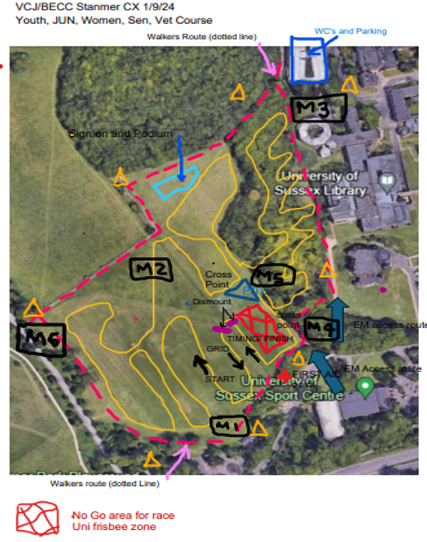

**Under 8/10/12 Course**

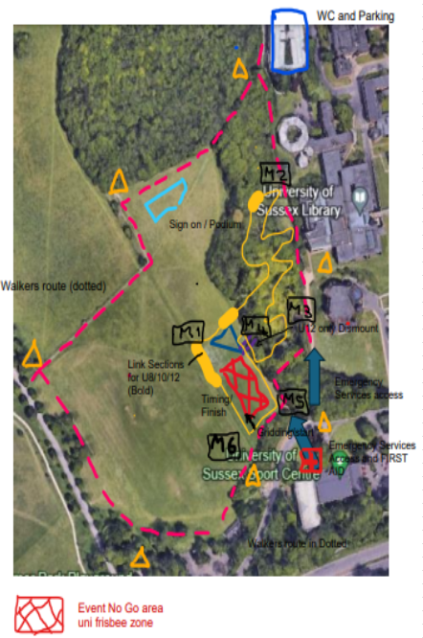

**Please note the pits are only shown for reference, they are not open during the U8/10/12 races.**

1. **Catering**

There is some water on site for the catering and drinking / refreshment’s. However there is not sufficient for extensive bike washes so please bring sufficient water for any bike cleaning you may need to do - please keep any bike washing to grassy woody areas and again be respectful - don’t leave mud in the car park please.

There will be some refreshments provided by the amazing VC Jubilee volunteers. The refreshments will be supported by generous assistance from Jeremys of Henfield and Jeremy's 2 Green Grocers.

## 

## **Parking**

**PARKING! The Parking is at a premium due to the Rugby so this year parking is pay per park. This opens up the use of the car parks at stammer park.**

**To ensure we have sufficient parking I have reserved parking for the event on the University campus. This will be sign posted with CX event signs to Car park 6 & 7 on the campus. The what3words location is /cheek.delay.stone. There is a height restriction of 2.1 metres for the multi-story (no roof racks!) and an unrestricted height "flat" car park with 90 spaces so non-restricted spaces are slightly limited. So please park in the multi-storey if your vehicle will fit.**

**The parking is pay per park** via the **paybyphone.co.uk** parking site. There are no cash meters taking payment so **do access their app or web site in advance** to speed up paying for your parking. **Costs are £3.10 for 4 Hours.**

## **Event Officials**

**Event Organiser** – James Stone

**Chief Marshal** – Ben Rodgers

**Chief Judge** – LCCA Timing Team

**Timekeeping** – LCCA Timing Team (Richard Hayes)

**British Cycling Chief Commissaire** – Chris Clague

**British Cycling Commissaire 2** – Stuart McGhee

**British Cycling Commissaire 3** – Dave Kahn

**Course Design** – Stone/Hodge/Gerry

**First Aid Provider** – Collingwood Medical Services

**Governing Body** – British Cycling

## **Race Programme and timetable**

|  |  |  |  |
| --- | --- | --- | --- |
| **Race** | **Gridding** | **Race Start** | **Duration** |
| Practice 1 U8/10/12 (Short Course Only) | **9am to 9.15am** | | |
| Under 10 | 9.15 | 9.20 | 10 mins |
| Under 8 (Line up behind the U10’s) | 9.15 | 9.20 | 10 mins |
| Under 12 | 9.35 | 9.40 | 15 mins |
| Practice 2 (Full Course) | **10am to 10.35am** | | |
| Under 14/16 | 10.35 | 10.40 | 30 mins |
| Junior + V40 Open | 11.20 | 11.30 | 40 mins |
| Female (All Cats) | 12.20 | 12.30 | 40 mins |
| Practice 3 | **13.20 to 13.45** | | |
| Vet 50/60/70+ Open | 13.45 | 13.50 | 40 mins |
| Senior Open | 14.40 | 14.50 | 60 mins |

**Practice times** – Please note that course open times are provisional as dependent on lap times and conditions. Please look for the green course open and red closed flags for accurate info on when you can get on course.

**Gridding** – Gridding will be created for each event race and advertised on the league results website and Facebook page before the event, any queries in gridding may be raised on Friday via email as posted on the results site. Please visit the London and South East Cyclo Cross League Website [rules section](http://www.londonxleague.co.uk/rules/) for a full explanation of how the gridding has been created.

## **Podium Presentation times and results**

|  |  |
| --- | --- |
| **Podium Presentation** | |
| U8/10/12 (18) | 10.15 |
| Youth (12) | 11.45 |
| Vet 40/Jun Open and All Female Categories (24) | 13.30 |
| Vet 50/60/70+ Open (9) | 15.00 |
| Senior/U23 Open (6) | 16.00 |

**Results**

Race Results and overall league tables will be published online as soon as feasible after each race. Race queries can be made up to 6pm on the Tuesday after each race by emailing [admin@londonxleagueresults.co.uk](mailto:admin@londonxleagueresults.co.uk). Once finalised, the results will be sent to BC to update the events page and allocate national rankings points.

## **Technical Regulations**

The event is run under the rules of the British Cycling Federation

<https://www.britishcycling.org.uk/cyclocross/article/bcst_rulebook_and_constitution?c=EN>

London and South East Cyclo Cross rules and info on league available here <http://www.londonxleague.co.uk/rules/>

Results will be published on the London and South East Cyclo Cross website and Facebook pages pretty much on the day of racing

Any queries on results please visit here for info how to do this [admin@londonxleagueresults.co.uk](mailto:admin@londonxleagueresults.co.uk).

## **First Aid and local hospitals**

First Aid is provided by:

Collingwood Services Ltd (part of the Collingwood Group)

Suite 5, Minton House

Amesbury Distribution Park, London Road

Amesbury SP4 7RT

Tel - 01980 623 820

[admin@collingwoodservices.co.uk](mailto:admin@collingwoodservices.co.uk)

## 

Local Hospitals:

Royal Sussex County Hospital,

Eastern Road,

Brighton,

BN2 5BE.